PLANNING WHITE PAPER (AUGUST 2020) AND ASSOCIATED CHANGES
Briefing Note

Planning Policy West Berkshire District Council

1. Introduction

1.1 The Planning White Paper (‘Planning for the Future’) was published on 6th August. It proposes the most fundamental change to the planning system since the current system was introduced in 1947. The document has been published for consultation, with an end date of 29th October. The proposal is to bring a draft response to the meeting of Council on 20th October.

1.2 Alongside the White Paper, a number of other planning changes are being consulted upon, over the same timescale, which would operate within the current system and would be introduced through national policy and legislation. This note also deals with those changes, and they would be included within the draft response to be considered by Council.

1.3 This note summarises the proposed changes. Whilst some commentary on implications for West Berkshire is included where appropriate, it does not form a full assessment of implications.

2. Planning White Paper

2.1 The Planning White Paper proposes a complete replacement of the current planning system that was established in 1947. It starts from the assumption that the current system is unfit for purpose and stands as a significant block on the development that the country needs, and, in particular, that it is responsible for the current housing crisis. The motivation for the overhaul is therefore to remove barriers to development.

2.2 At its heart, the White Paper proposes a form of zoning system, whereby the use of all land is defined at the plan-making stage, which means that the planning application process is substantially reduced. Zoning systems exist in many other countries, including most European countries, but the current proposals do not seem to be based on any existing systems from elsewhere.

2.3 The White Paper is based around the following three pillars:
- Pillar One – Planning for Development
- Pillar Two – Planning for Beautiful and Sustainable Places
- Pillar Three – Planning for Infrastructure and Connected Places

2.4 The following are some of the main elements to be aware of in Pillar One – Planning for Development:

- Local Plans would be fundamentally changed, to become first and foremost map-based, using a standard national template and software, dividing all land in their area into three categories: ‘growth’, ‘renewal’ and ‘protection’.

- Land for ‘growth’ would be suitable for substantial development (with substantial being defined in policy), i.e. comprehensive development/redevelopment. Inclusion in the Local Plan would automatically confer outline approval or permission in principle. Flood zones would be excluded (unless risk can be fully mitigated).

- Land for ‘renewal’ would be suitable for development, which would cover existing urban areas, and include infill, town centre development etc, with the Local Plan specifying which development would be suitable where. There would be a statutory presumption in favour of development for the uses specified, and this will include some kind of automatic permission where a development complies with the specifications of the plan. This is referred to as a ‘fast-track to beauty’ process.

- Land for ‘protection’ will be land where more stringent controls apply, either defined nationally or locally on the basis of policies in the NPPF (the implication being that local authorities would not have scope to invent their own protection categories). These could include Green Belt, Areas of Outstanding Natural Beauty, Local Wildlife Sites, local green spaces and conservation areas. Here, a planning application would be required as is the case currently. The paper states that this can include back gardens. It is worth noting that the automatic permission in a ‘growth’ area does not seem be reflected in an automatic refusal in a ‘protection’ area.

- It is likely that most of West Berkshire would be protected as shown below:

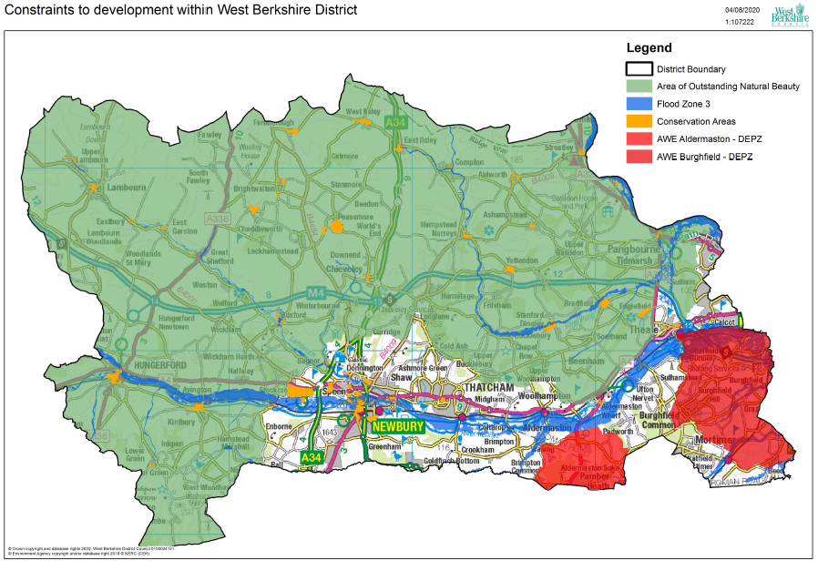

- Policy in the local plan would be restricted to clear and necessary area- or site-specific parameters, such as height and density. General development management policies would be set out in national policy only.

- Design guides and codes would be produced for local areas and either included within the plan or later as a Supplementary Planning Document.

- Many of the plan-making requirements would be removed, for instance sustainability appraisal, duty to co-operate and the tests of soundness, and would be replaced with a simpler ‘sustainable development’ test.

- A binding housing figure would be set at a national level through a standard methodology. This methodology would take account of constraints as well as need, unlike the current methodology, which is based on need only.

- There would be a statutory 30 month timetable for Local Plan production (for comparison, the new Local Plan Review is taking around 5 years to prepare to adoption). The new process would include only two consultation stages – an initial call for ideas/sites, and consultation on a full draft after the plan has been submitted. Authorities would have either 30 months (where there is no recent plan) or 42 months (where there is a recent plan) to adopt a new plan after the legislation comes into force. The White Paper envisages that engagement will be made much more extensive and effective at the plan-making stage, to make up for loss of consultation opportunities at planning application stage, but the only proposals for how this can be achieved seem to be to base it on new technology and social media.

- Neighbourhood plans would be retained, but how they would fit in an entirely new system is unclear. As is their need for renewal.

- There would be faster decision-making through new technological solutions (e.g. more automated validation, machine-readable documents), reduction on information requirements (e.g one short planning statement), standardisation of technical reports and data, standard national conditions, template decision notices. There would also be delegation to officers to decide applications where the principle is established.

- The Paper proposes refunding application fees where an application goes over statutory time limits (with no scope to negotiate extensions), and potentially a deemed consent in those cases. There would also be an automatic rebate of the application fee if an appeal is successful.

2.5 The following are some of the main elements of Pillar Two – Beautiful and Sustainable Places:

- A National Model Design Code will be published in autumn 2020, accompanied by a revised Manual for Streets.

- Local design guides and design codes should be produced either as part of the Local Plan or as SPD, but will only be given weight if effective input from the local community can be demonstrated. Without local design codes, developments should comply with the national design code.

- A new national expert body on design and place-making will be set up, which will assist local authorities with design codes, and every local authority will be expected to appoint a chief officer for design and place-making.

- There will be a fast-track process for developments which comply with design codes in areas for ‘growth’ and ‘renewal’ in the Local Plan. There will also be a widening of permitted development rights to allow “popular and replicable” forms of development, according to a pattern book, in ‘Renewal’ areas.

- There is continued commitment to various elements of the Environment Bill, including biodiversity net gain, as well as a national expectation on trees, and the continued push for the Future Homes standard and development to be net zero carbon by 2050.

- Environmental Impact Assessment processes would be simplified.

- There would be an updated framework for listed buildings and conservation areas. The government also want to look at whether some simple listed building consents can be dealt with by suitably experienced specialists in the industry.

2.6 Finally, the following are the main elements of Pillar Three – Planning for Infrastructure and Connected Places:

- The Community Infrastructure Levy and Section 106 agreements would be abolished, and replaced with a new Consolidated Infrastructure Levy.

- Rather than a charge per sq m of floorspace, the new Levy would be based on a proportion of the final value of a development, over a certain threshold. It would make the Levy more responsive to market conditions, but means the actual contribution would not be known until the development is completed, and may well be zero if the development value falls below the threshold. It would also only be paid on occupation, so there would be no contributions at earlier development stages. Local authorities could borrow against future levies so they can forward fund infrastructure.

- The rate would be set nationally. It may be a single rate across the country, or more regionally based. It would continue to be collected and spent locally.

- The Levy may be extended to cover more developments that benefit from permitted development rights, for instance where there is no new floorspace.

- The Levy would cover affordable housing, which could be secured on-site through the levy or be an off-site payment. The implication is that the amount of affordable housing would therefore also be set nationally.

- There is potentially more freedom on spend, and this could include provision of council services and reducing council tax. The Paper also proposes that a proportion should be kept to cover planning service costs on Local Plans, enforcement, etc.

2.7 Finally, the government would develop a comprehensive resourcing and skills strategy. This will include greater regulation of pre-application fees. The proposal is to work closely with the property technology (‘PropTech’) sector to roll out much greater digitalisation. There may be more enforcement powers, and local authorities are expected to be able to refocus on enforcement due to less application requirements.

  - Some of the key themes running through the White Paper are therefore as follows:

- A very significant level of deregulation, trying to remove barriers to development and create much greater certainty within the planning process.

- There is also a very significant centralisation of powers on government. There would be nationally-set development management policies, national standard conditions, nationally set CIL (including affordable housing), binding nationally-set housing numbers through a standard methodology, a national design guide taking precedence where no design codes are in place, a national body to support local design codes etc.

- Removal of opportunities for democratic oversight and local consultation, which for many developments will only take place as part of a slimmed down local plan process. The roles of Planning Applications Committees would inevitably be substantially reduced.

- The proposed procedures are in many cases highly dependent on as-yet-untested technological solutions. Government plans to work on this with the technology sector to develop systems, but the record of national IT projects continues to be not good, and a substantial risk is that new legislation will be introduced before the technology is in place to support it.

- There would need to be significant investment in design skills. Much of the day-to-day work of planning sections may change from general policy and development management to drawing up strong design codes, and skills would need to improve in these areas.

2.8 For every proposal, the White Paper sets out alternative options, which are usually watered-down versions of the proposal. No change is rarely an option.

2.9 The timetable for introducing changes is not set out in detail, but the government have stated that they would like to see the new generation of local plans in place by the end of this parliament, which would require legislation to be in place by the beginning of 2022 at the latest.

3. Other Changes to the Planning System

3.1 Alongside the White Paper, another consultation document has been published that proposes a number of changes to the existing planning system. These would not require primary legislation, and would be brought in in advance of the White Paper through national policy, most likely a Written Ministerial Statement. The expectation is that this would happen this year. It is not clear whether these are transitional changes until the new system is introduced or whether they would be retained as part of a new system.

3.2 The four changes are as follows:
- A revised standard methodology for calculating housing need;
- The introduction of ‘First Homes’;
- An increased threshold for requiring affordable housing; and
- Extension of the ‘permission in principle’ process.

Standard methodology for housing need
3.3 There is currently a national standard methodology for assessing housing need which local plan-making needs to take account of. It is based on national household projections, with a multiplier based on the local affordability ratio, with a cap set at a 40% increase over existing housing figures.

3.4 The main changes can be summarised as follows:
- Introducing an alternative baseline to household projections, which is a 0.5% annual growth on existing dwellings in the area, intended to reinforce existing settlement patterns. Whichever is the higher of these two baselines would be used.
- As well as the local affordability ratio, the changes in affordability over the last ten years are also factored in, creating a much greater weighting on affordability.
- The cap based on a proportion of existing policy targets would be removed.

3.5 Based on this approach, using most recent available information, West Berkshire’s need would be 693 homes per annum.

First Homes
3.6 First Homes is a new affordable housing product, largely to replace Starter Homes, and is defined as homes to be sold at a minimum 30% discount to local first-time buyers in need of housing. The discount would apply in perpetuity. The proposal is that at least 25% of on-site affordable housing contributions will be First Homes, mandated by national policy. National policy currently requires that 10% of all housing on sites of over 10 dwellings would be for affordable home ownership products, and is largely delivered as shared ownership. The favoured approach is that First Homes will be in place of other affordable ownership products, i.e. mainly shared ownership. This will leave us free to continue defining the tenure for the remainder.

3.7 Local authorities can also set a higher level of discount, e.g. 40 or 50%, if local circumstances justify it. However, the document does state that this would need to be evidenced through the local plan-making process. Evidence produced for the Local Plan Review continues to support West Berkshires 30% Brownfield land and 40% Green field land development as well as for all developments of 5 or more in rural areas.

3.8 It is worth noting that the 25% First Homes requirement would also apply to off-site financial contributions, meaning that a quarter of financial contributions to affordable housing would need to be spent on First Homes.

Affordable Housing Thresholds
3.9 The consultation proposes raising the site threshold for providing affordable housing from 10 units to 40 or 50 units, for an initial time-limited period of 18 months to enable SME developers to recover from Covid-19. The assumptions are that this would result in a 7-14% (if 40 units) or 10-20% (if 50 units) reduction in affordable housing delivery.

3.10 The consultation states that the government would monitor the impacts on the sector before reviewing the approach. However, it is worth noting that very similar wording was used when office to residential permitted development rights were introduced in 2013, and these were of course rolled forward and made permanent. There is a strong possibility that this threshold could similarly be rolled forward after the initial period.

3.11 West Berkshire is in an unusual position nationally, in that we do not apply the existing threshold in any case, and this has been supported at appeal. Officers’ working assumption is that we would continue to apply our own local policies, but we would need to be aware that we may face fresh challenges on this at appeal, and potentially from some larger and better-resourced developers.

Permission in Principle
3.12 A ‘permission in principle’ application route has been in place for a couple of years, in which an application can be made for permission in principle for housing-led development on sites of up to 10 dwellings. This then needs to be followed by a technical details consent stage, at which the detailed matters are considered.

3.13 The proposal is to extend the ‘permission in principle’ application route to include major developments, up to 150 dwellings or 5 hectares (which is the Environmental Impact Assessment limit). A time period of 5 weeks would continue to apply to these larger developments, as would the same, very minimal, requirements in terms of information submission. The consultation asks if height parameters should be included at permission in principle stage, or left to technical details consent stage. It is proposed to keep fees low and based on the area of the site rather than dwelling numbers, which may not be known until the technical details are applied for.

3.14 The permission in principle route has been little-used in West Berkshire so far, as it offers few clear advantages for minor development over the outline and reserved matters route. However, for major developments, a 5-week route to some form of consent may prove very attractive. Fees based on site area rather than dwelling numbers may also provide a challenge on predicting future planning income.

https://assets.publishing.service.gov.uk/government/uploads/system/uploads/attachment_data/file/907647/MHCLG-Planning-Consultation.pdf
https://assets.publishing.service.gov.uk/government/uploads/system/uploads/attachment_data/file/907215/200805_Changes_to_the_current_planning_system_FINAL_version.pdf

